Security Doors - Executive Ranger >>>
ER1 | ER2 | ER3
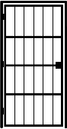 | 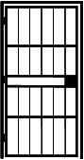 | 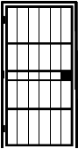
ER4 | ER5 | ER6
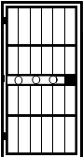 |  | 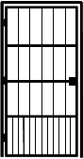
ER7 | ER8 | ER9
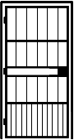 | 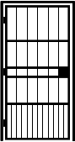 | 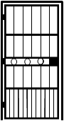
 | ER10
 | 